Summer MMXVI

Urbs Romana: The Roman City!
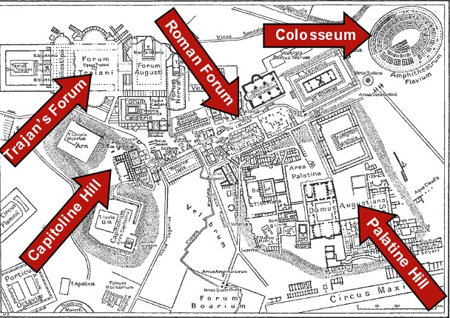

Latin II Summer Work: This is a little review intended as a warm up before classes begin in September. The packet should be completed and brought to school on the first day of class There is a copy on Hopewell Valley Latin – The Latin II Web Page
- Verb Review: Memorize Principle Parts and Complete Synopses
- Review Demonstrative Pronouns: Hic and Ille; Memorize Hic/Haec/Hoc Chart

Part I City Vocab Verbs
- Verbs Vocab: Memorize all principle parts of the verbs below
Notice most verbs have 4 basic forms called principle parts (some have 3); can you find patterns among the principle parts of the verbs below?

- Adoro, adorāre, adoravi, adoratus- to adore, worship
- Doceo, doēre, docui, doctus- to teach
- Doleo, dolēre, dolui, - to hurt, be in pain
Memorize the principle parts of these verbs!
- Edo, esse, edi, essus- to eat
- Excedo, excedere, excessi, excessus- to go out
- Facio, facere, feci, factus- to do, make
- Festino, festināre, festinavi, festinatus- to rush, hasten
- Laudo, laudāre, laudavi, laudatus- to praise
- Lavo, lavāre, lavi- to wash
- Nato, natāre, natavi- to swim
- Specto, spectāre, spectavi, spectatus- to watch, see
- Sum, esse, fui, futurus- to be

- Complete the Synopses: Sort and Translate
- Specto, spectare, spectavi, spectatus : 3rd s.= he/she
Spectare, spectabat, spectabit, spectabitur, spectat, spectabatur, spectator, specta/spectate

 | Active | Passive
 | 2nd 2nd 2nd p.p. | 2nd 2nd 2nd p.p.
Present
Imperf
Future
Infinitive
Imperative

2. Laudo, laudāre, laudavi, laudatus 1st pl= we
Lauda/laudate, laudabamus, laudamus, laudabimus, laudamur, laudabamur, laudabimur, laudare

 | Active | Passive
 | 2nd 2nd 2nd p.p. | 2nd 2nd 2nd p.p.
Present
Imperf
Future
Infinitive
Imperative
3. Sum, esse: 3rd pl = they
Erant, esse, sunt, es, erunt, este

 | Active | Passive
 | 2nd 2nd 2nd p.p. | 2nd 2nd 2nd p.p.
Present
Imperf
Future
Infinitive
Imperative

4. Nato, nature, natavi 2nd pl= y’all
Natatis, Nata/Natate, Natabatis, Natabitis, Natare

 | Active | Passive
 | 2nd 2nd 2nd p.p. | 2nd 2nd 2nd p.p.
Present
Imperf
Future
Infinitive
Imperative

5. Lavo, lavare, lavi 1st S. = I
Lavare, Lavebo, Lavebam, Lavo, Lava/lavate!

 | Active | Passive
 | 2nd 2nd 2nd p.p. | 2nd 2nd 2nd p.p.
Present
Imperf
Future
Infinitive
Imperative

Pars II: Pronouns Charts
Memorize Your Demonstrative Pronoun: Hic Haec Hoc!
This and That: Hic/Haec/Hoc This/These
 | Masc | Fem | Neuter | English
Nom | Hic | Haec | Hoc | This
Gen | Huius | Huius | Huius | Of this
Dat | Huic | Huic | Huic | To/for this
Acc | Hunc | Hanc | Hoc | This
Abl | Hoc | Hac | Hoc | By/with this
Nom | Hi | Hae | Haec* | These
Gen | Horum | harum | Horum | Of these
Dat | His | His | His | To/for these
Acc | Hos | Has | Haec* | These
Abl | His | His | his | By/with these
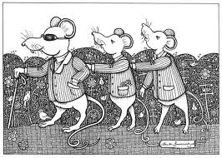
Sing it: To the tune of 3 blind mice
Hic, haec, hoc, this and these
Huius times 3, and huic times 3
Hunc, hanc, hoc, hoc, hac, hoc, hi, hae, haec
And horum and harum and horum too,
Then after dative his 3 times its
hos, has, haec, his 3 times


Learn Hic/haec/hoc carefully!
Review Ille/Illa/illud: That/Those
 | Masc | Fem | Neuter | English
Nom | ille | illa | illud | That
Gen | illius | illius | illius | Of that
Dat | illi | illi | illi | To/for that
Acc | illum | illam | illud | That
Abl | illo | illa | illo | By/with that
Nom | illi | illae | illa | Those
Gen | illorum | illarum | illorum | Of those
Dat | illis | illis | illis | To/for those
Acc | illos | illas | illa | Those
Abl | illis | illis | illis | By/with those

