Latina I
Lingua Latina I.1: Intro to Latin; Esse; Nouns; Map
Lesson I  F-9/7 | Salutationes  Pronunciation  Map- Lege et Converte  Sum, Esse  PD Practice Pronunciation Online
Lesson II  B-9/9  Veneris Dies | Salutationes  Practice Pronunciation/Gaudeamus  Sum, Esse Practice  Map II  PD Review for Pronunciation and Sum, Esse Quiz
Lesson III  C-9/12  Lunae Dies | Excita: Pronunciation Review  Pila Perfecta: Sum, Esse  Quiz: Pronunciation and Sum, Esse  Nouns and Vocab  PD Fac Cartas Vocabulorum
Lesson IV  D-9/13  Martis Dies | Excita: Vinco  Grammar II: Nouns  Noun Practice  PD Crossword; Memorize Singular and Plural Noun Endings
Lesson V  B-9/15  Iovis Dies | Excita Pila: Singular and Plural Nouns  Imperium Romanum Project  PD Map Workbook
Lesson VI  C-9/16  Veneris Dies | Excita SWAT: Singular and Plural  Imperium Project Presentations  PD Review Vocab for Test LLI.1
Lesson VII  D-9/19  Lunae Dies | Excita: Noli Errare E Via  Practice Test  Map Review  PD Study for Test Lingua Latina I.1
Lesson VIII  B 9/21  Mercolis Dies | Test Chapter I  Vocab; Sum, esse; Nouns; Map  PD Vocabula Lingua Latina II- Fac Cartas
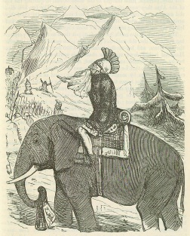

Latina I: Lingua Latina I
Goals:
1. Verbs: All 6 forms of “esse”
2. Nouns: Recognize and Discriminate 1st/2nd and 2nd neuter
Singular and plural Nominative
3. Numbers 1- 10
4. Pronunciation
5. Map
-------------------------------------------------------------------------------------------------------------------------------------

Next Chapter- continuation- directions/map with genitive

Vocabula: Lingua Latina I
Latine | Anglice | Derivative
NOMENA
1. fluvius, fluvii
2. insula, insulae |  | Peninsula= paene/insula; insulated, insular
3. oppidum, oppidi |  | ---------------------------
4. oceanus, oceani |  | Ocean
5. imperium, imperii |  | Imperial, Empire,
6. provincia, provinciae |  | Province, Provincial
7. numerus, numeri |  | Numeral, numerous, numerical
8. littera, litterae |  | Literature, literal
9. vocabulum, vocabuli |  | Vocabulary
10. capitulum, capituli |  | Capital, chapter
11. pensum, pensi |  | Pensive, pension
ADIECTIVI
12. magnus, magna, magnum | Big
13. parvus, parva, parvum | Small
14. Graecus, Graeca, Graecum | Greek
15. Romanus, Romana, Romanum | Roman
16. Latinus, Latina, Latinum | Latin
17. Multus, multa, multum | Many
18. paucus, pauca, paucum | Few
Verbi
19. Sum, esse, fui, futurus | To be
Misc
20. In | In
21. Et | And
22. Sed | But | ---------------------------------------
23. Non | Not
24. Quoque | Also | --------------------------------------
25. -ne? | ? | --------------------------------------
26. Ubi? | Where? | ---------------------------------------
27. Num? | Isn’t? | ---------------------------------------
28. Quid? | What?
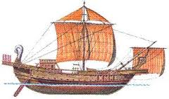

Verb of the Week: Sum, Esse
Sum, esse, fui, futurus

Ego/I | Sum | Nos/we | sumus
Tu/you | Es | Vos/y’all | estis
Is, ea, id  s-he,it | est | Ei/eae/ea  they | sunt

I. Translate:
1. ego sum:__________
2. nos sumus:_______
3. tu es:_____________
4. vos estis:_________
5. est:_______________
6. sunt:_____________
7. Roma est in Italia:_________________
8. Vos in Italia estis:______________
9. Nos sumus in Germania:_____________________
10. Germania et Italia in Europa sunt:________________________
11. Sicilia est insula:____________________________
12. Sicilia et Britannia sunt insulae:________________________________

II. Scribe:
1. We are: ____________ 2. Y’all are:______________
3. They are:_____________ 4. He is:____________
5. I am:_____________ 6. You are:___________
7. We are in Africa:____________________________
8. You are in Egypt:________________________
III. Make it Plural
Singular | Plural
1. est-
2. sum-
3. es-
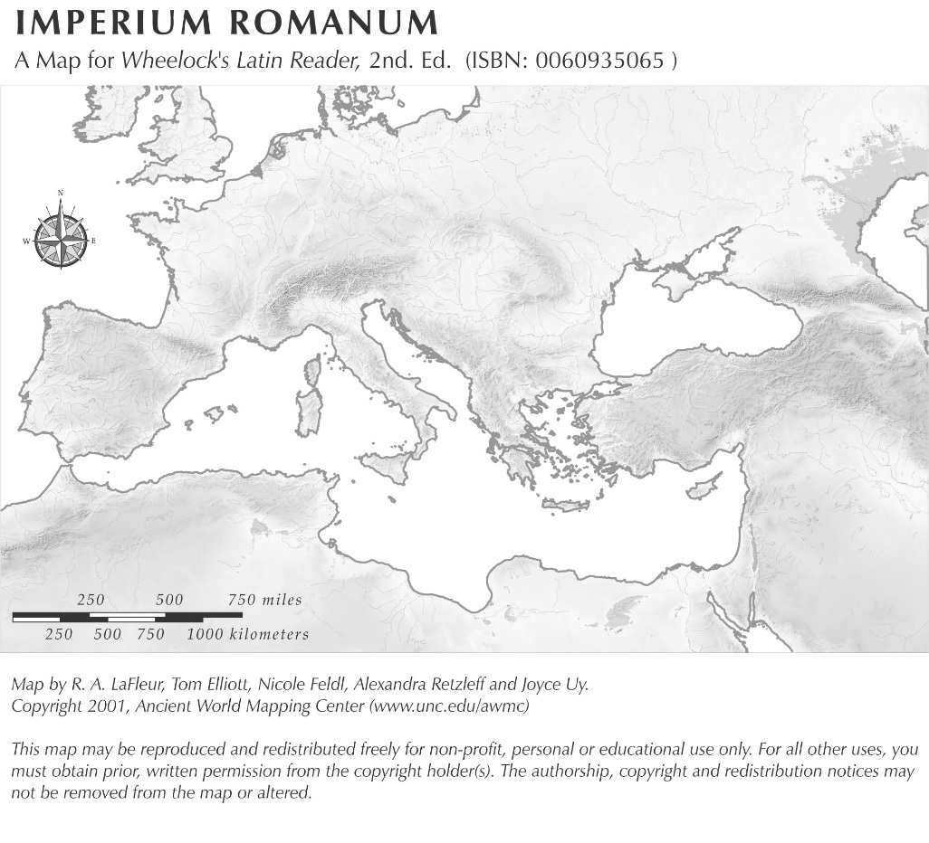

Noun Knowledge
I. Noun patterns I- 3 types of nouns
 | Prima = 1st  Feminina | Secunda= 2nd  Masculina* | Secunda = 2nd  Neutra*
Description
Exempla

(from vocab list)

- Based on your work above can you describe why there are 3 forms of an adjective in Latin? Look at your vocab list and compare the adjective endings to the noun endings. What do you think?

I. Sort the list of nouns below:
Porcus, porci femina, feminae villa, villae Aegyptus, Aegypti Brundisium, Brundisii familia, familiae templum, templi collum, colli

Prima = 1st  Feminina | Secunda= 2nd  Masculina* | Secunda = 2nd  Neutra*
Can you guess the meaning of the terms above?

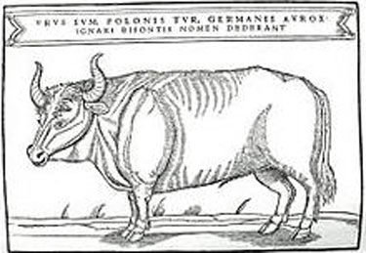

Noun Knowledge II- Singular vs. Plural
Singular and Plural Nouns in English:

Latin Endings
 | Prima = 1st  Feminina | Secunda= 2nd  Masculina* | Secunda = 2nd  Neutra*
Nominative
Singular
Nominative
Plural

I. Make it Singular/Plural
Singular | Plural
1. insula | Insulae
2. fluvius
3. oppidum
4. syllaba
5. capitulum
6. | Pensa
7. | Litterae
8. | Numeri
9. oceanus
10. | Imperia

II. Converte/ Scribe
1. Nilus fluvius est._____________________________________
2. The Nilus and the Rhenus are rivers:_____________________________
3. Brundisium oppidum est.____________________________________
4. Brundisium and Tusculum are towns:
_______________________________________________
5. Sardinia est insula magna._______________________________________
6. Sardinia and Sicilia are big islands:
____________________________________________________________________
7. Africa is a large province.____________________________________
8. Africa et Asia sunt provinciae magnae.
____________________________________________________________
9. Where are you?_____________________________________
10. I am in Italy._______________________________________
11. Where are we?_____________________________________
12. We are in Greece.__________________________________
III. Perfecta Sententiae
1. Sicilia _________________ est.
2. Italia insula _________ est.
3. Brundisium_____________est.
4. Sicilia et Sardinia _______________magnae sunt.
5. Britannia non ___________parva, sed ___________ ________________est
6. Est___ Brundisium in Graecia?
7. Brundisium _______ est in Graecia, _________in Italia.
8. ___________est Sparta?

Latina I
Lingua Latina I.1: Intro to Latin; Esse; Nouns; Map
Lesson I  F-9/7 | Salutationes  Pronunciation  Map- Lege et Converte  Sum, Esse  PD Practice Pronunciation Online
Lesson II  B-9/9  Veneris Dies | Salutationes  Practice Pronunciation/Gaudeamus  Sum, Esse Practice  Map II  PD Review for Pronunciation and Sum, Esse Quiz
Lesson III  C-9/12  Lunae Dies | Excita: Pronunciation Review  Pila Perfecta: Sum, Esse  Quiz: Pronunciation and Sum, Esse  Nouns and Vocab  PD Fac Cartas Vocabulorum
Lesson IV  D-9/13  Martis Dies | Excita: Vinco  Grammar II: Nouns  Noun Practice  PD Crossword; Memorize Singular and Plural Noun Endings
Lesson V  B-9/15  Iovis Dies | Excita Pila: Singular and Plural Nouns  Imperium Romanum Project  PD Map Workbook
Lesson VI  C-9/16  Veneris Dies | Excita SWAT: Singular and Plural  Imperium Project Presentations  PD Review Vocab for Test LLI.1
Lesson VII  D-9/19  Lunae Dies | Excita: Noli Errare E Via  Practice Test  Map Review  PD Study for Test Lingua Latina I.1
Lesson VIII  B 9/21  Mercolis Dies | Test Chapter I  Vocab; Sum, esse; Nouns; Map  PD Vocabula Lingua Latina II- Fac Cartas

Audite et Scribe
Rhenus est fluvius in Germania.
Rhenus non est fluvius parvus, sed fluvius magnus est.
Danuvius quoque est Fluvius in Germania.
Rhenus et Danuvius sunt fluvii magni.
Our Crossword Puzzle
 | ¹ |  |  |  |  |  |  |  |  | ² |  |  |  |  | ³
⁴ |  |  |  | ⁵
 |  |  |  |  |  |  |  | ⁶
 |  |  |  |  |  |  |  |  |  |  |  |  |  |  | ⁷
 |  |  |  |  |  |  |  | ⁸ |  | ⁹
 |  |  |  | ¹⁰
 |  |  |  |  |  |  |  |  |  | ¹¹
 |  |  |  |  |  | ¹²

ACROSS  4. Fluvius in Italia  6. Brundisium est oppidum in...  7. Quot syllabae sunt in Sicilia?  9. Sardinia et Creta sunt...  10. Insula magna sub Italia  11. Hispania est ___________Romana  12. Quot litterae sunt in Sicilia? | DOWN  1. Fluvius in Aegyptus  2. Sparta est oppidum in...  3. Tusculum et Sparta sunt...  5. Fluvius in Germania  8. Rhenus est _______________in Europa
If you wish to print the above crossword, make sure your browser settings are correct.

